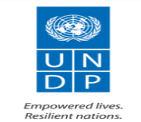
SUPPORT FOR STABILIZATION AND EARLY RECOVERY OF THE CONFLICT-AFFECTED COMMUNITIES IN NORTH-EAST NIGERIA
Project Number: 00134399
Output Number: 00129603

2023 Quarter Two Progress Report
(Apr – Jun 2023)

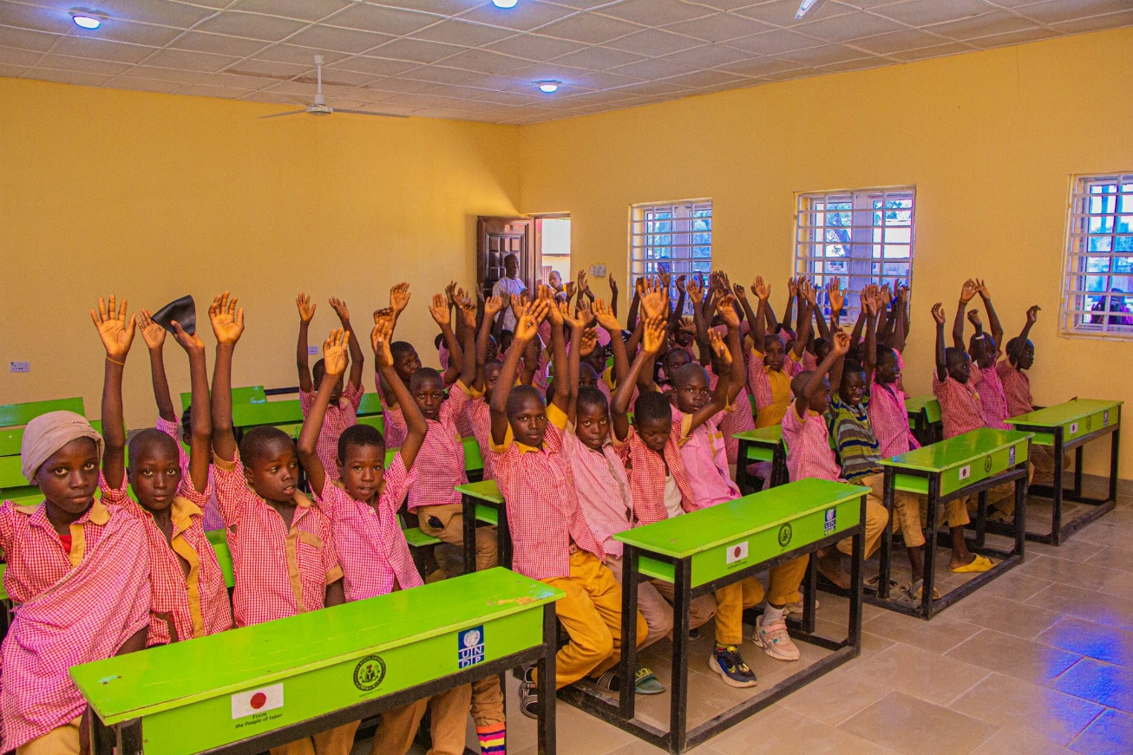
The handover ceremony of Garkida primary school, June 2023, Yobe SEMA (Bakura Mohammed, UNDP)

Project Summary | Country: Nigeria  Project Duration: 21 March 2022 – 20 June 2023 (12 months + non-cost extension 3 months)  Project Budget: US$ 4,277,166  Annual Budget: US$ 1,481,719  Cumulative expenditure (including for the reporting period): US$ 1,347,228.96  Contact Persons: <Name of Unit Team Leader>  Head of Sub-office Northeast, Moncef Kartas  Tel. +234-9012272918  Email: moncef.kartas@undp.org  <Name of Project Manager>  Project Manager, Hiroko Konno  Tel. +234-911 206 4998  Email: hiroko.konno@undp.org
  Donor | Annual budget US$
  Japan | 1,481,719
Responsible Parties: Adamawa State Emergency Management Agency (ADSEMA), Borno State Ministry of Reconstruction, Rehabilitation and Resettlement (MRRR), Yobe State Emergency Agency (YOSEMA), Adamawa State Agricultural Development Programme (ADADP), Borno State Agricultural Development Programme (BOADP), Yobe State Agricultural Development Programme (YOADP) and FinPact Consulting

Table of Contents
Acronyms 4
1. Executive Summary 5
2. Situation Background 6
3. Progress towards development results 6
3.1 Contribution to longer term results 6
3.2 Progress towards project outputs 8
3.3 Overall impact of the project 10
3.4 Human Interest Story 10
4. Cross cutting issues 11
4.1 Gender results 11
4.2 Partnerships 11
4.3 Environmental Considerations 11
4.4 South to South and Triangular Cooperation 12
4.5 Strengthening national capacity 12
5. Monitoring and Evaluation 13
5.1 Risk management 15
6. Challenges 15
7. Lessons Learned 15
8. Evidence 16
9. Financial Summary 16

Acronyms

ADADP | Adamawa State Agricultural Development Programme
ADSEMA | Adamawa State Emergency Management Agency
BOADP | Borno State Agricultural Development Programme
EoJ | Embassy of Japan
IDPs | Internally Displaced Persons
JICA | Japan International Cooperation Agency
MRRR | Borno State Ministry of Reconstruction, Rehabilitation and Resettlement
NCE | Non-cost extension
SGBV | Sexual and Gender Based Violence
VSLA | Village Savings and Loan Association
YOADP | Yobe State Agricultural Development Programme
YOSEMA | Yobe State Emergency Agency

Executive Summary

All civil works except Dikwa trench have been completed. This will contribute to CPD Outcome: the increase in citizens’ confidence and satisfaction in public service delivery.

960 participants in the vocational training received financial support while the transaction for 40 youths in Borno state could not be completed. VSLAs in 33 communities have been supported, and 18 communities have received financial support for VSLAs. Five communities with new VSLAs have benefitted support to savings fund, while the contribution has allocated to social funds in 13 communities with existing VSLAs. All civil works except Dikwa trench were completed. The completion of Dikwa trench has been discussed with Borno MRRR. The handover of Garkida primary school was held on 8 June 2023. The handover of Jajere primary health care centre is planned for July 2023. Then the number of beneficiaries from the public facilities will be revealed. All activities of Output 3 were completed by the first quarter of 2023.

The pupils of Garkida primary school suffered from studying in packed classrooms due to the limited number of classrooms before the project. Now the pupils can study in a more comfortable environment. The final evaluation of the project by an independent evaluator is under preparation. The final evaluation will provide more detailed information on the impacts of the project.

To be completed, the construction of the Dikwa trench requires further assistance in the Dikwa community. A commander requested certain actions to be taken before the backfilling of an old trench and the movement of troops to the new tranche site: All existing tangos should be relocated, and new additional tangos should be built in the new tranche site. The lighting system at the tranche area (solar lights). Sanitation facilities at the tranche area (latrines and showers). Water facilities (drilling of new boreholes). These requirements for the completion of the backfilling have not been foreseen at the beginning of the project, and the project does not have sufficient resources and time to meet them. Close consultations with all stakeholders are necessary to verify the scope of work of the project at the beginning of the project.

2023 budget is US$ 1,481,719. The expenditure during the reporting period is US$ 1,347,228.96 (expenditure rate 91%).

Situation Background

In the 1960s and 1970s, the North-East region of Nigeria flourished as an economic hub. However, due to poverty, governance neglect, and environmental degradation, the region has experienced a decline in productive investment. This decline has led to an increase in insecurity and terrorism in the region.. The Boko Haram insurgency, which began in 2009, has exacerbated the situation, resulting in the destruction of basic infrastructure, health and educational facilities, commercial buildings, private houses, and agricultural assets. The insecurity has also led to unemployment and low economic participation, with a large percentage of agricultural lands inaccessible due to military restrictions. The situation in the North-East region has had a particularly devastating impact on women and children, with rampant Sexual and Gender Based Violence (SGBV) including denial of access to services, physical violence, and survival sex. To address these challenges, the UNDP is implementing a project aimed at supporting stabilization and early recovery in the conflict-affected communities in the North-East region of Nigeria. Building on the lessons and successful results of former UNDP projects in the region, the project will use an integrated community stabilization and resilience-building approach to achieve three key outcomes: (1) improving the livelihood and economic opportunities of target communities, (2) restoring basic services and strengthening local governance in target states, and (3) strengthening mechanisms for enhancing social cohesion and community security.

The operation of some contractors was suspended for some weeks due to the elections in February and March 2023, added with Government restrictions in Adamawa state and the security situation in Borno. This affected the progress of civil works. The request of a non-cost extension (NCE) for three months (until 20 June 2023) was sent to the Embassy of Japan (EoJ) on 21 March 2022. The approval for the NCE by the EoJ was granted on 31 March.

Progress towards development results

Contribution to longer term results

United Nations Sustainable Development Cooperation Framework (UNSDCF)/Country Programme Document (CPD) Outcome #1 : By 2027 more inclusive, participatory, transparent and gender-sensitive governance, justice and human rights systems are in place at all levels to promote acceleration in achieving the 2030 Agenda and SDGs for a peaceful, inclusive, and cohesive society.

Summary achievements based on CPD Outcome #1 targets
CPD outcome target | Summary achievement to date | Status
CPD 2018-2022 #1  Percentage of citizens that have confidence and satisfaction in good governance and public service delivery  Target: 30% | All civil works except Dikwa trench have been completed. This will contribute to the increase in citizens’ confidence and satisfaction in public service delivery. The handover of Garkrida primary school was held in June 2023. The handover of Jajere primary health care centre was done in July 2023. | Ongoing
Overall |  | Ongoing

Relevant CPD 2023-2027 Output 3.5 : Communities affected by violent conflict enabled to regain lost livelihoods, infrastructures and basic services for durable socioeconomic development and restoration of local economy.
Summary achievement based on CPD output targets
CPD output targets | Summary achievement to date (provide gender disaggregation) | Status
Indicator 3.5.1.: Number of people benefiting from improved infrastructure for recovery in crisis or post-crisis settings disaggregated by sex.  Target: 3,770  Indicator 3.5.2.: Percentage of households benefiting from jobs and improved livelihoods disaggregated by sex.  Target: 60% | All civil works except Dikwa trench have been completed. This will contribute to the two indicators. The handover of Garkida primary school was held in June 2023. The handover of Jajere primary health care centre was also held in July 2023. 960 participants of vocational training have received financial support for their businesses. | Ongoing
Overall status |  | Ongoing

Progress towards project outputs
Project Output 1: Livelihood and economic opportunities of the target communities are improved.
Summary achievement against 2023 Annual Work Plan (AWP) target
Indicator (as they appear in the AWP) | Indicator Target (2023)  (AWP indicator targets) | Summary achievement during the quarter (provide gender disaggregation) | Status:
1.1 Number of Households of farmers improved their livelihood with supports | 2,000 (including at least 400 female-headed households) | 2,000  (Including 433 female-headed households) | Completed in 2022
1.2 Number of micro and small enterprises and entrepreneurs supported | 900 entrepreneurs or business owners (including at least 360 women) | 960 (432 women, 528  men) | Ongoing
1.3 Number of youths with improved skill in vocational training and supported with business start-up grants (by gender) | 1,000 (including no less than 400 women) | 1,000 (445 women, 555  men) | Completed in 2022
1.4 Number of VSLA members who get loan and make repayment in repetition | 1,500 (including no less than 600 women) | 0 | Ongoing
 | Overall status |  | Ongoing
Description of Results
960 participants in the vocational training received financial support while the transaction for 40 youths in Borno state could not be completed. VSLAs in 33 communities have been supported, and 18 communities have received financial support for VSLAs. Five communities with new VSLAs have benefitted support to savings fund, while the contribution has allocated to social funds in 13 communities with existing VSLAs. The VSLAs have 2,958 active members (1,355 women and 1,603 men). The collection of infomation on the indicator 1.4 is under way.

Project Output 2 Basic services are restored with local governance strengthened in target communities
Summary achievement against 2023 Annual Work Plan (AWP) target
Indicator (as they appear in the AWP) | Indicator Target (2023)  (AWP indicator targets) | Summary achievement during the quarter (provide gender disaggregation) | Status:
2.1 Number of people benefitting from improved basic services in the community | 5,200 (including no less than 2,080 women) | 0 | Ongoing
2.2 Number of workers employed under the civil works | 1,050 (including no less than 105 women) | 270 (27 women, 243 men) | Completed in Q1-2023
2.3 Number of labour days created | 14,700 days (including no less than 1,470 days for women) | 3,511 days (415 for women, 3,096 for men) | Completed in Q1-2023
2.4 Number of state and/or local government officials equipped with skills for effective governance | 3 | 6 (6 men) | Completed in 2022
2.5 Number of LGAs in which community dialogue process has been strengthened | 40 | 21 | Completed in Q1-2023
 | Overall status |  | Ongoing

Description of Results
All civil works except Dikwa trench were completed. The completion of Dikwa trench has been discussed with Borno MRRR. The handover of Garkida primary school was held on 8 June 2023. The handover of Jajere primary health care centre is planned for July 2023. Then the number of beneficiaries from the public facilities will be revealed.

Project Output 3: Mechanisms for enhancing social cohesion and community security is strengthened
Summary achievement against 2023 Annual Work Plan (AWP) target
Indicator (as they appear in the AWP) | Indicator Target (2023)  (AWP indicator targets) | Summary achievement during the quarter (provide gender disaggregation) | Status:
3.1 Number of community platforms strengthened and promoting cohesion in communities | 12 | 5 | Completed in Q1-2023
3.2 Number of community members participate in training to prevent SGBV | 1,800 (including no less than 720 women) | 1,800 (731 women and 1,069 men) | Completed in Q1-2023
3.3. No. of advisory groups for protection and counselling for SGBV victims | 12 | 5 | Completed in Q1-2023
 | Overall status |  | Completed
Description of Results
All activities of Output 3 were completed by the first quarter of 2023.

Overall impact of the project
The pupils of Garkida primary school suffered from studying in packed classrooms due to the limited number of classrooms before the project. Now the pupils can study in a more comfortable environment. The final evaluation of the project by an independent evaluator is under preparation. The final evaluation will provide more detailed information on the impacts of the project.

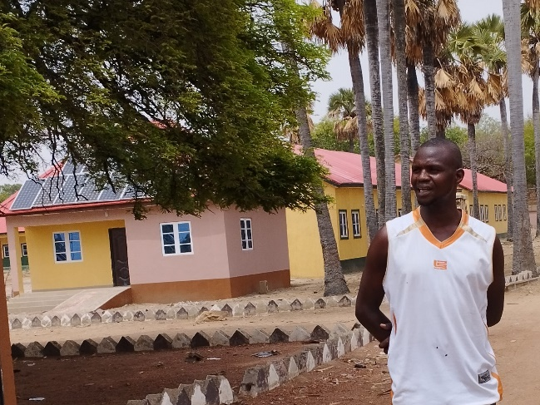
Human Interest Story
My name is Ibrahim Saleh, male, 28 years old and a resident of Garkida, a town that bore the scars of conflict and destruction. I am a skilled mason and two of my friends, Isa Bale and Modu Kolo, are a carpenter and a plumber respectively. Our life and that of others changed forever when the United Nations Development Programme (UNDP) intervened with some transformative projects that brought hope and renewal to our community. The Cash for Work component of the UNDP program became the catalyst for my personal journey of growth and empowerment. Like many others in Garkida, I had lost everything during the conflict, and I found myself without any means of livelihood. The UNDP program arrived in our community, offering an opportunity for individuals like me to participate in the reconstruction efforts through the Cash for Work initiative. The concept was simple yet powerful: we would be employed to help build the very structures that were vital to our community's revival. I joined the program without hesitation. With each passing day, as I worked alongside fellow beneficiaries, a sense of purpose and pride began to take root within me. We were not just rebuilding structures; we were rebuilding our hope as well. I learned valuable construction skills that I never imagined I would possess. From laying bricks to mastering plumbing work. The income I earned through the Cash for Work program not only provided for my basic needs but also allowed me to plan. Today, the once-ravaged town of Garkida is beginning to flourish again as more schools and healthcare facilities have been provided by the UNDP Early Recovery Program.

Cross cutting issues

Gender results
Gender results | Evidence
Gender result 1: In general, a VSLA has three groups: youth, woman and elder groups. VSLA women groups have been supported. | Evidence 1: The interim and final report of the partner (Finpact)
The target beneficiaries are vulnerable community members and internally displaced persons (IDPs) particularly women and youth, who have been disproportionately impacted by the violence and who have lost their means of livelihoods. Based on the special consideration for women, the project document stipulates the target percentage and number of female beneficiaries. The achievement of the indicators has been monitored and recorded.

Partnerships
The project team closely oversaw the implementation of Activity 1.4 (VSLA) by the private sector partner (Finpact). In particular, guidance on the selection of actions, such as the allocation of financial support to savings and social funds and capacity building, within the limited project period.

Environmental Considerations
The project complied State Government construction laws and regulations through the use of locally sourced, low-impact materials such as construction aggregates and designing for energy efficiency which optimized natural lighting and ventilation of the facilities. This practice had a positive impact on the environment and helped to address challenges of climate change. The project engaged with local communities, relevant stakeholders (the school-based management committee), and the local leadership authority before and during construction activities. This helped identify potential environmental concerns and aided development of strategies to mitigate identified environmental. To minimize the environmental impact of the project construction sites, the project team implemented a waste management strategy at our project housing construction sites. The project repurposed excavated materials for substructure filling and safely disposed of excess waste. This approach significantly reduced the amount of waste generated and effectively mitigated our impact on the environment.. The construction projects successfully preserved the existing economic plants and wildlife habitats without any negative impact..

South to South and Triangular Cooperation
Country | Type of cooperation
- Japan | Japanese expert from JICA participated in the UNDP-JICA joint workshop in Abuja mentioned above.

Strengthening national capacity
Results achieved | Institution | National capacity strengthened
- Governance Capacity Building in North-East Nigeria | The BAY state governments and 21 LGA in the BAY states | The experiences in recovery activities and their results by LGAs were shared

Monitoring and Evaluation
Key M&E activities conducted during the quarter [ensure alignment to section 3 - how progress was evaluated]
Key M&E activity (monitoring visit, evaluation, review exercise) | Key outcomes/ observation | Recommendation | Action taken
Monitoring activity 1  Project steering committee (review) by Hauwa, Hiroko and Joseph (M&E) | The progress, results and roadmap of the project was presented by the Project steering committee members. Lessons learnt, comments, observations and suggestions were recorded. | - The monitoring of project implementation and data collection should be improved for effective reporting.  - The project should establish synergy with other projects of UNDP in the BAY states, especially in SGBV and conflict/risk management issues. | - UNDP would organise a capacity-building workshop on M&E and communication for the partners for a new project.  - The ER project team will communicate with other project teams of UNDP about the development and implementation of projects.
Monitoring activity 2  Monitoring visits to Dikwa trench by Hauwa, Ahmad and Owinzi | - Clearance of 85 Ha of Topsoil: 100% completed  - Excavation of new trench of 8 Km: 3.3 Km (41%)  - Backfilling of an old trench of 2 Km: Not completed yet  Backfilling cannot be completed until the request of security forces is fulfilled. | The construction of a trench under the project would be terminated after discussions with Borno MRRR. A contractor needs to complete 80% which the project has already paid for. | Discussions on this issue with Borno MRRR will be hold.
Monitoring activity 3  Monitoring visits to Garkida by Ahmad, Owinzi and Hiroko | Furniture/equipment and the functionality of an entire solar system were inspected.  The handover ceremony of the facilities of Garkida primary school was held.  Some minor defects were observed | Observed defects:  - Nonfunctioning of the reticulation work from the borehole to the constructed facilities  - Improper functioning of the fetching points  - Minor leakages observed on the ceiling  - No provision made for draining of wastewater from the taps onto the floor of the constructed toilets.  - Make all WCs rigid | The project team will follow up with contractors on the correction of the defects.
Monitoring activity 4  Monitoring visits to Jajere by Owinzi and Ahmad | All civil works were completed | Organise the handover ceremony of Jajere primary health center | The PHC was handed over Tuesday 25th July 2023.

Risk management
Risks | Mitigation Measures
Deterioration of the security situation and intensification of militia activity, especially around the period of the elections  Drastic Change of policy by the Government  Non- respect of commitments by implementing partners or any other stakeholders (company, supplier, local government)  Delays in the processes of staff recruitment and selection of consultants and suppliers  Inaccessibility of intervention sites due to the deterioration of road conditions | Close monitoring of the security situation, rescheduling of monitoring missions, suspension of activities (esp. Civil works) and the request for non-cost extension.  Close communication and coordination with the new Government  Close monitoring the implementation rate of the project partners  Support with staff on a detail assignment  Close monitoring with the security unit.

Challenges
To be completed, the construction of the Dikwa trench requires further assistance in the Dikwa community. A commander requested certain actions to be taken before the backfilling of an old trench and the movement of troops to the new tranche site: All existing tangos should be relocated, and new additional tangos should be built in the new tranche site. The lighting system at the tranche area (solar lights). Sanitation facilities at the trench area (latrines and showers). Water facilities (drilling of new boreholes). These requirements for the completion of the backfilling have not been foreseen at the beginning of the project, and the project does not have sufficient resources and time to meet them. The rainy season too makes it difficult for the excavation to continue.

Lessons Learned
Close consultations with all stakeholders are necessary to verify the scope of work of the project at the beginning of the project. Government commitment in terms of full utilization of the facilities which include deployment of personnel to facilities is also crucial. The effective implementation of the Cash for Work Initiative played a crucial role in addressing the short-term employment needs of the participants, promoting resilience and building a foundation for sustainable growth in the vulnerable communities.

Evidence

Report Section | Title | URL link
3.2  3.3 | UNDP Nigeria with funding from the Government of Japan handed over the refurbished Garkida North Primary School, Adamawa.  Yobe, UNDP Commission Primary Healthcare Centre In Jajere | https://twitter.com/UNDPNigeria/status/1668256364110524419  https://www.instagram.com/p/Ctg0qLaM74n/?igshid=MTc4MmM1YmI2Ng%3D%3D  https://allnews.ng/news/yobe-undp-commission-primary-healthcare-centre-in-jajere

Financial Summary
Outputs / Activity Result |  | Current Annual Budget (US$)  (Jan – Dec 2023) | Expenditure (Reporting Period) | Cumulative Expenditures | % Expenditure  (Cumulative)
 |  | A | B | D | D/A*100
Output 1: Livelihood and economic opportunities of the target communities are improved
Activity Result 1.1 | Support farmers with agricultural extension services and supplementary provision of agricultural inputs | 0 | 0 | 0
Activity Result 1.2 | Support small businesses and entrepreneurs with training, start-up kits business plan development, and cash grant | 236,000 | 167,749.78 | 167,749.78
Activity Result 1.3 | Support youth with vocational training in the areas inc. machinery, tailoring, knitting, animal rearing, and auto mechanic | 0 | 1,267.29 | 1,267.29
Activity Result 1.4 | Support Village Saving and Loan Associations (VSLA) with capacity development and matching grants | 194,400 | 150,899.85 | 150,899.85
Output 1 Sub-total |  | 430,400 | 319,916.92 | 319,916.92 | 74%
Output 2: Basic services are restored with local governance strengthened in target communities
Activity Result 2.1 | Prepare technical documents for community infrastructures and provide quality control | 10,500 | 651.56 | 651.56
Activity Result 2.2 | Contract with construction companies for rehabilitation or reconstruction of public facilities with employment of residents | 673,613 | 639,206.93 | 639,206.93
Activity Result 2.3 | Provide the public facilities with necessary furniture and equipment | 0 | 155,367.32 | 155,367.32
Activity Result 2.4 | Capacity enhancement of state and local governments on recovery process in partnership with JICA | 0 | 19,481.44 | 19,481.44
Output 2 Sub-total |  | 684,113 | 814,707.25 | 814,707.25 | 119%
Output 3: Mechanisms for enhancing social cohesion and community security is strengthened
Activity Result 3.1 | Conduct peace dialogues to enhance reconciliation and promote tolerance among communities | 27,000 | 17,690.62 | 17,690.62
Activity Result 3.2 | Conduct training and set up of community groups to prevent and respond to SGBVs | 20,000 | 13,345.55 | 13,345.55
Output 3 Sub-total |  | 47,000 | 31,036.17 | 31,036.17 | 66%
Project Management Cost (incl. direct project costing)
 | Staffing | 128,464 | 57,564.61 | 57,564.61
 | Travel, office rent, and others | 15,493 | 23,109.71 | 23,109.71
 | Global monitoring, advocacy, and reporting | 13,724 | 0 | 0
 | DPC | 56,989 | 0 | 0
Project Management Sub-total |  | 214,670 | 80,674.32 | 80,674.32 | 38%
GMS (8%) |  | 105,536 | 100,894.30 | 100,894.30
Grand total |  | 1,481,719 | 1,347,228.96 | 1,347,228.96 | 91%
N.B. Expenditure (Reporting period) contains expenditures in the first quarter because they could not be captured for the previous/the first quarter report.

